CS337 System Programming

Programming Assignment #6 Due Wednesday, November 1st, 11:59pm
Topics: Files + File Streams in C.

For this assignment, you need only write a single-file C program. Your program will:
- Define a C structure ( contact struct ) suitable to hold the defining characteristics of a:
Sample (char* name, int list_len, float* value_list) - call this format a Sample data record.

- Write a separate function to :
Read a file (created in a text editor – pico) of delimited Sample data records into an array of pointers to your sample structs. Note: you may use a statically sized array of size 1024, however, each element of the array must be a pointer to a sample struct (as defined above). Initially each element of the array must be set to NULL (to indicated that it is not used), and then later to a dynamically allocated sample struct if it is to be used.
Note: after dynamically allocating memory for a sample struct, you have enough memory for each/every component of the structure. However, for each component of that structure that is a pointer, you will eventually need to allocated memory for the “thing” that it points to as well (think string via char* , arryay via float*). You will also have to remember this when freeing memory via a pointer to a sample struct.

- Write a separate function to :
Create a new file and write all the “used” elements of the array ( of sample struct s ) to this file. You must use binary writes for all of C's built-in numeric types.

- Write a separate function to :
Free all of the “used” elements of the array ( of sample struct s ) – that means all the memory that was allocated for each element ( the structure and its components ).

- Write a separate function to :
Read a file of your sample struct s, ( as it was created by your second function ) and display

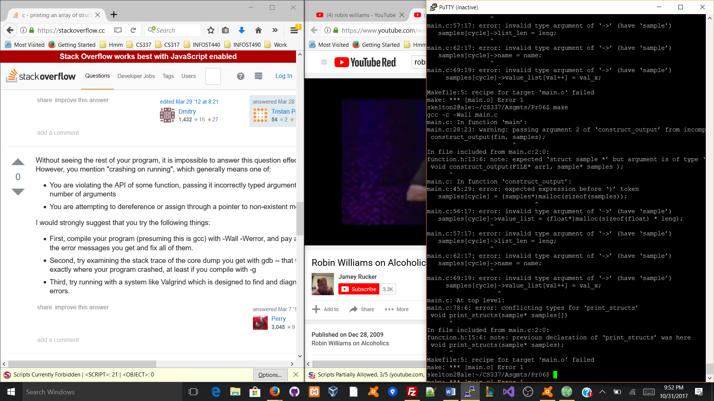each in a reasonable report like format to the screen.

